Remote sensing for vegetation monitoring

Activity 2: Exploring vegetation productivity in Europe with the Copernicus Land Monitoring Service (CLMS) (approx. 30 minutes)

Copernicus is the Earth Observation component of the European Union’s space programme, looking at our planet and its environment for the benefit of Europe’s citizens.

The Copernicus Land Monitoring Service (CLMS) - https://land.copernicus.eu/en - provides geographical information on land cover and its changes, land use, ground motion, vegetation state, water cycle and earth surface energy variables for both Europe and the entire globe.

Objective:
Gain an introduction to how satellite remote sensing research supports the understanding and monitoring of vegetation trends using the Copernicus Land Monitoring Service map viewer. Students will explore a variety of approaches and products used to map key bio-geophysical variables, including vegetation properties, indices, seasonal trajectories, phenological patterns, and productivity, enhancing their understanding of how Earth observation contributes to environmental monitoring.

- Lauch the Copernicus Land Monitoring Service (CLMS) Map viewer: https://land.copernicus.eu/en/map-viewer
- From the headings at the left, expand Bio-geophysical Variables, and then Vegetation.

The Plant Phenology Index (PPI): The Plant Phenology Index (PPI) is a satellite-derived vegetation index designed to closely reflect the photosynthetic activity and biomass of vegetation. PPI is linearly related to leaf area and chlorophyll content.

- Total productivity - global dataset

Provides the growing season integral computed as the sum of all daily Plant Phenology Index values between the dates of the season start and end.

- Expand Vegetation Phenology and Productivity Parameters
- Check the box Total Productivity 2023-preent (raster 300m) global to view this data
- This provides the growing season integral computed as the sum of all daily Plant Phenology Index values between the dates of the season start and end.

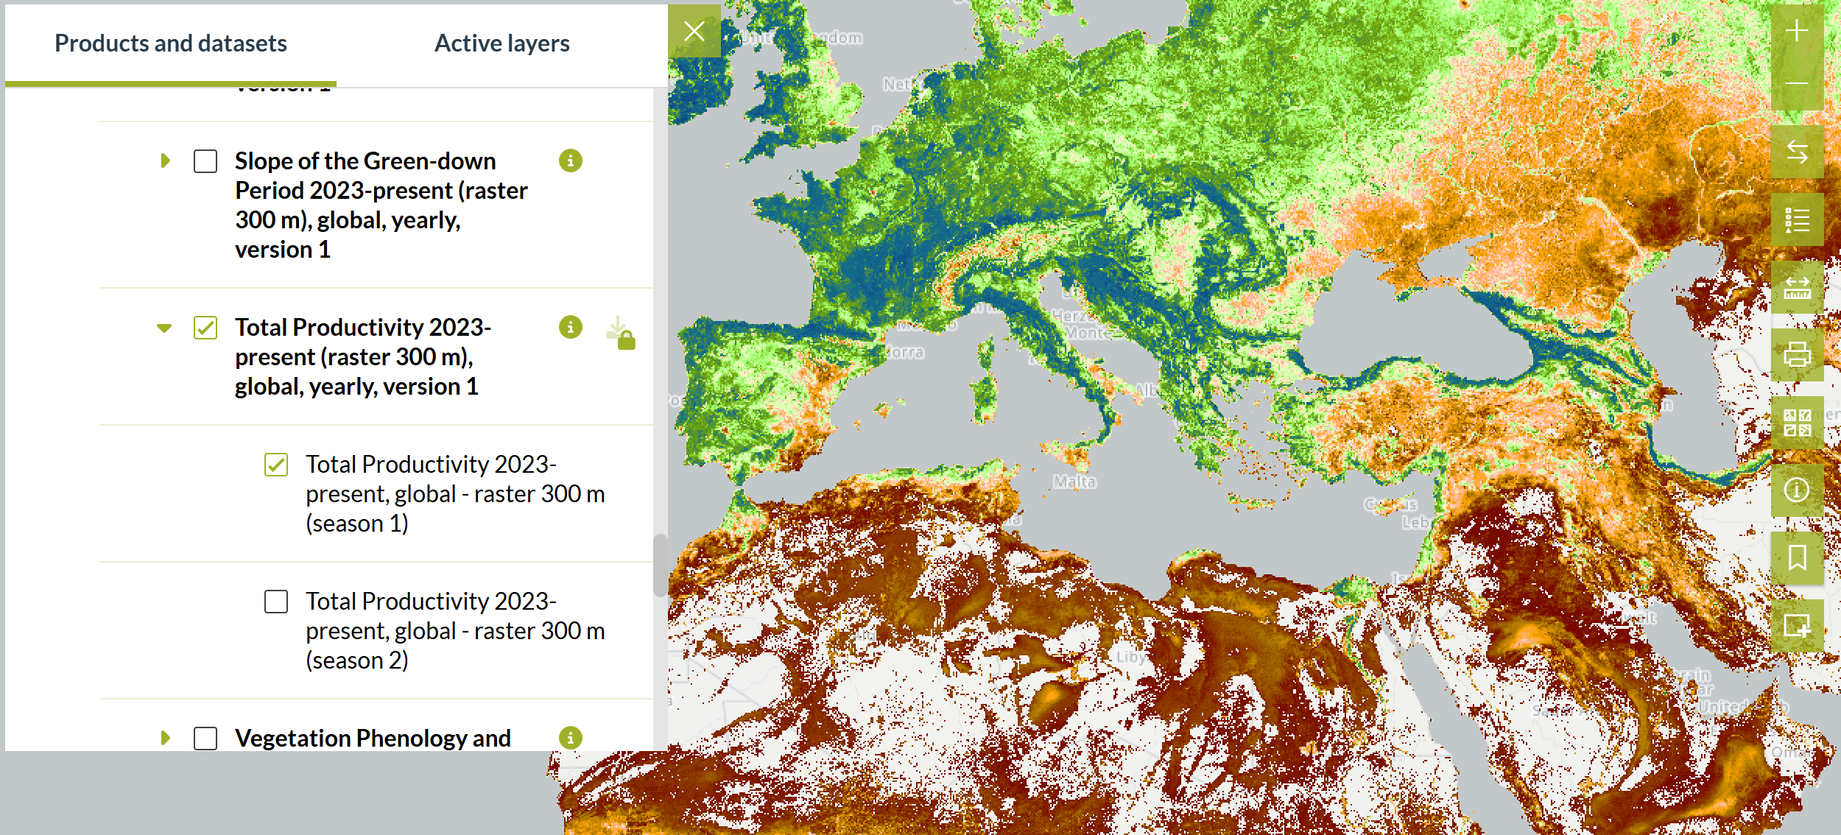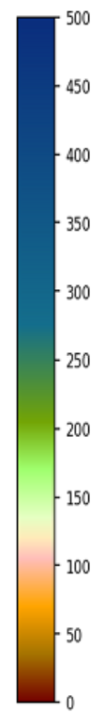

- Plant Phenology Index - Europe

- Close all datasets.
- Expand Vegetation Seasonal Trajectories
- Check the box Plant Phenology Index Seasonal Trajectories 2017-present (raster 10), Europe, 10-daily to view this data. This is a filtered time series with a regular 10-day time step.
- Zoom in on an area you are familiar with, e.g. where you live.
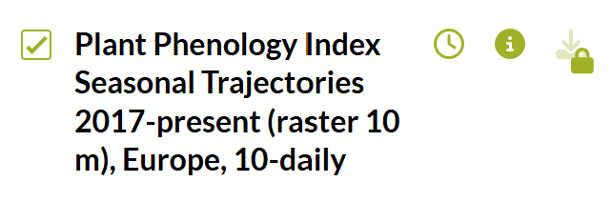
- Click the clock icon next to the data layer to open the time slider.

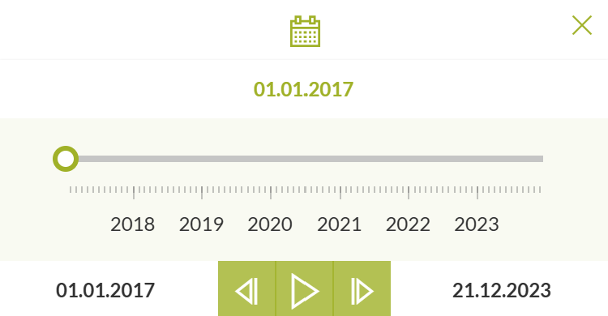
- You now see a time slider with the date of the data viewed.

- Click the “play button” for a 10-day step animation.
- You can clearly see with this amination the time lapse of the vegetation growing seasons.

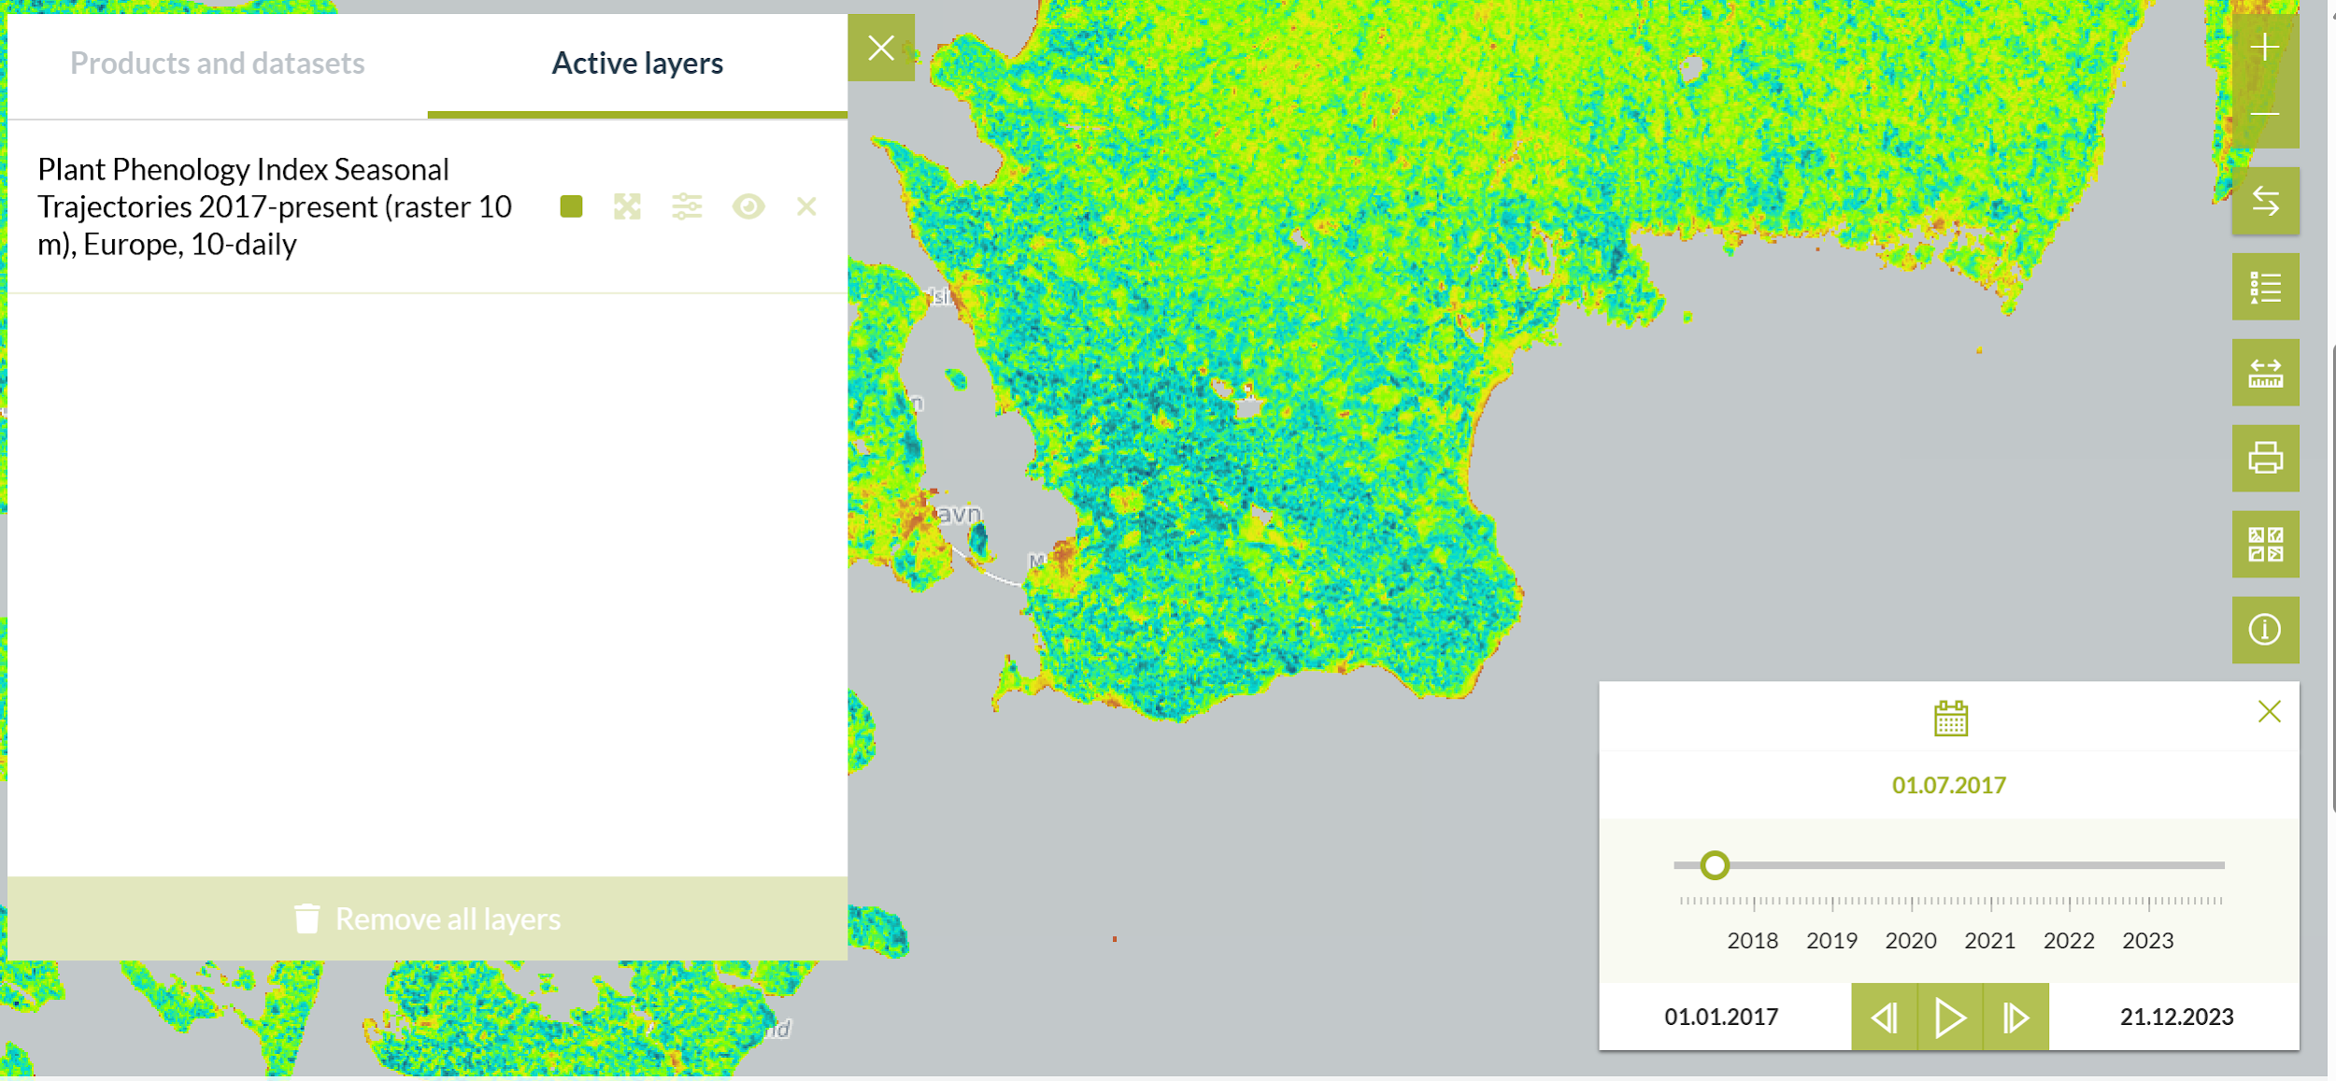

With such data, we can analyse trends in the timing of the start of the growing season, the length of the growing season, end dates of the growing season, geographical shifts of productive areas etc.

