Remote sensing for vegetation monitoring

Activity 1: Exploring deforestation trends in Google Earth and Global Forest Watch (approx. 30 minutes)

Objective:
This exercise is to engage students in exploring deforestation trends in Brazil using Google Earth Pro and Global Forest Watch. Through simple spatial analysis and visual interpretation, students may identify patterns of forest loss, investigate the impact on biodiversity and Indigenous lands and examine the economic and policy drivers behind deforestation. Such an exercise encourages critical thinking about the environmental, social, and global implications of land use change, while also building skills in interpreting satellite data, using geospatial tools, and communicating evidence-based insights.

Part 1: Historical images to explore deforestation in the Amazon

- Download Google Earth Pro or use the web version: https://www.google.com/intl/en/earth/versions/
- Seach for the State of Rondônia, Brazil and zoom in on the area. Note that at the bottom of the image you can see the date of the image you are looking at.
- Notice how there are very sharp and straight borders for some deforestation areas. Why could this be?
- Use function to ”Show historical imagery” 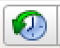 . Go back to the mid-80s to find a location with major changes.
- Note the coordinates in decimal degrees of your location (under Tools > Options you can change the format of your coordinates)

Students should take some time to search on the Internet and families themselves on the main causes/drivers for deforestation in the Amazon – or tropical deforestation in general.

Part 2: Global Forest Watch

Global Forest Watch (https://www.globalforestwatch.org/) is an online platform that provides near-real-time data, maps and analysis tools to monitor forests and track deforestation around the world. The data comes from satellite images that are automatically classified. Here, you can get e.g. statistics on the reduction of forest areas and tree cover for specific areas between 2001 and 2024.

- Open the map service: https://www.globalforestwatch.org/map/
- Click on the search option from the left menu.
- Start by finding the Location > Rondônia, Brazil (search under tab Location). The map will zoom in on the area.
- Make a first analysis of the political boundary of Rondonia by clicking the area on the map.
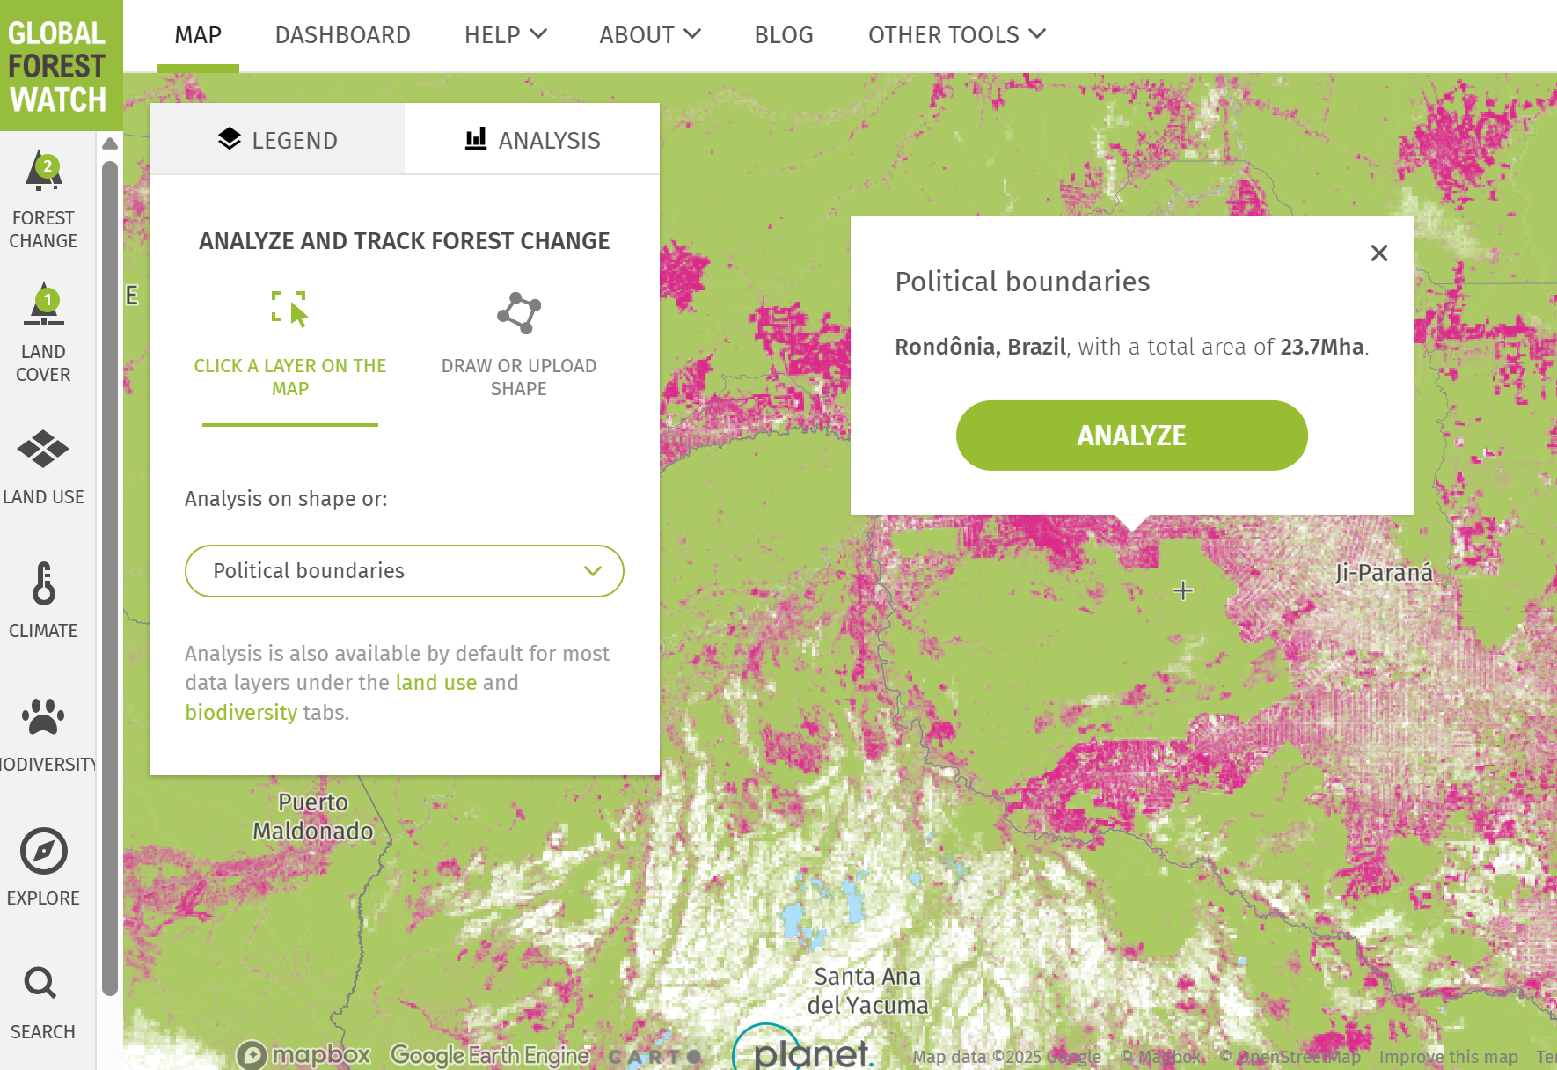

- You now get a dashboard with the facts and statistics on forest and tree cover changes for that administrative area.
- Now try to search with Decimal degrees > and enter the coordinates of the location you have identified in Part 1, e.g.:
latitude: -11.xxxxxx
longitude: -62.xxxxxx
- When clicking Go to position, the map is centered on that location. Click on the map to return to it.
- Now, under the tab Analysis, choose Draw or upload shape and create a polygon around your coordinate. You now get facts and statistics for your area of interest.

Note that the GFW site includes a Help section with resources to guide you through the forest monitoring data, technology and tools that Global Forest Watch offers.

Part 3: explore deforestation in your own country/region

Follow the steps above to find out what happens in your neighbourhood.

